Eigenstate
By Martin Grider (pnp rules v1.2)

Rules

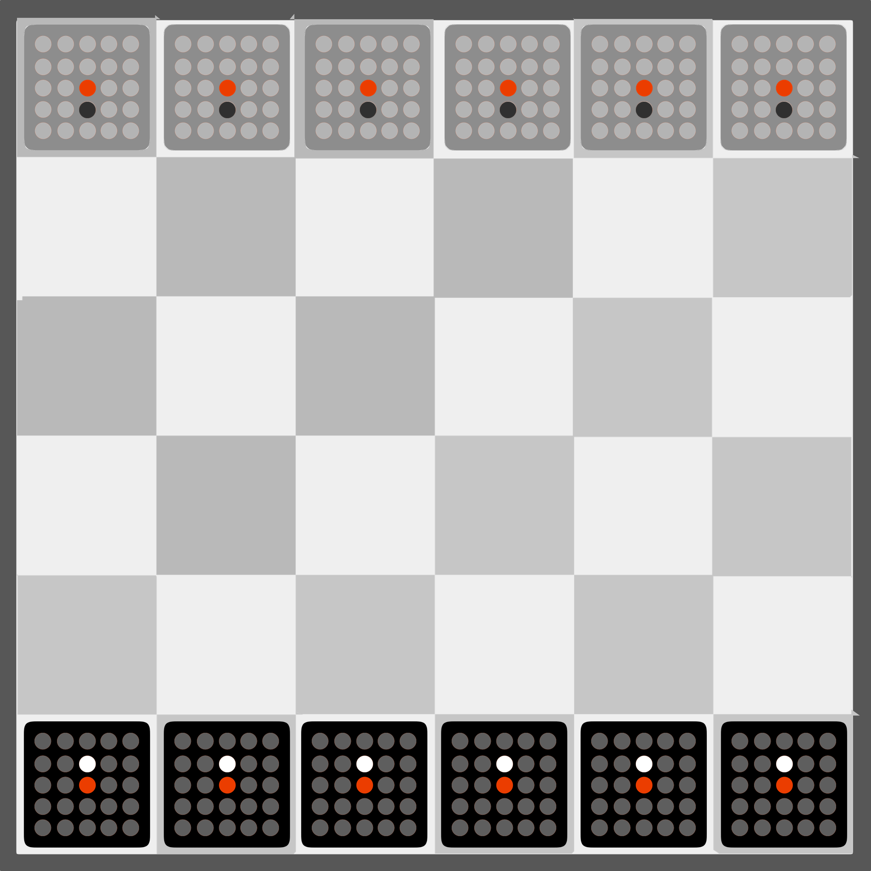
Setup
Each player selects a color and takes all the pieces of that color and sets them on the row of the board closest to the player. Every piece starts with two pegs in it: a peg in the center representing its position on the board, and one additional peg allowing the piece to move one space forward.

Gameplay
On a player's turn, in this order, if they can, they must:
- Move one of their pieces.
- Then place 2 pegs in any of their pieces.

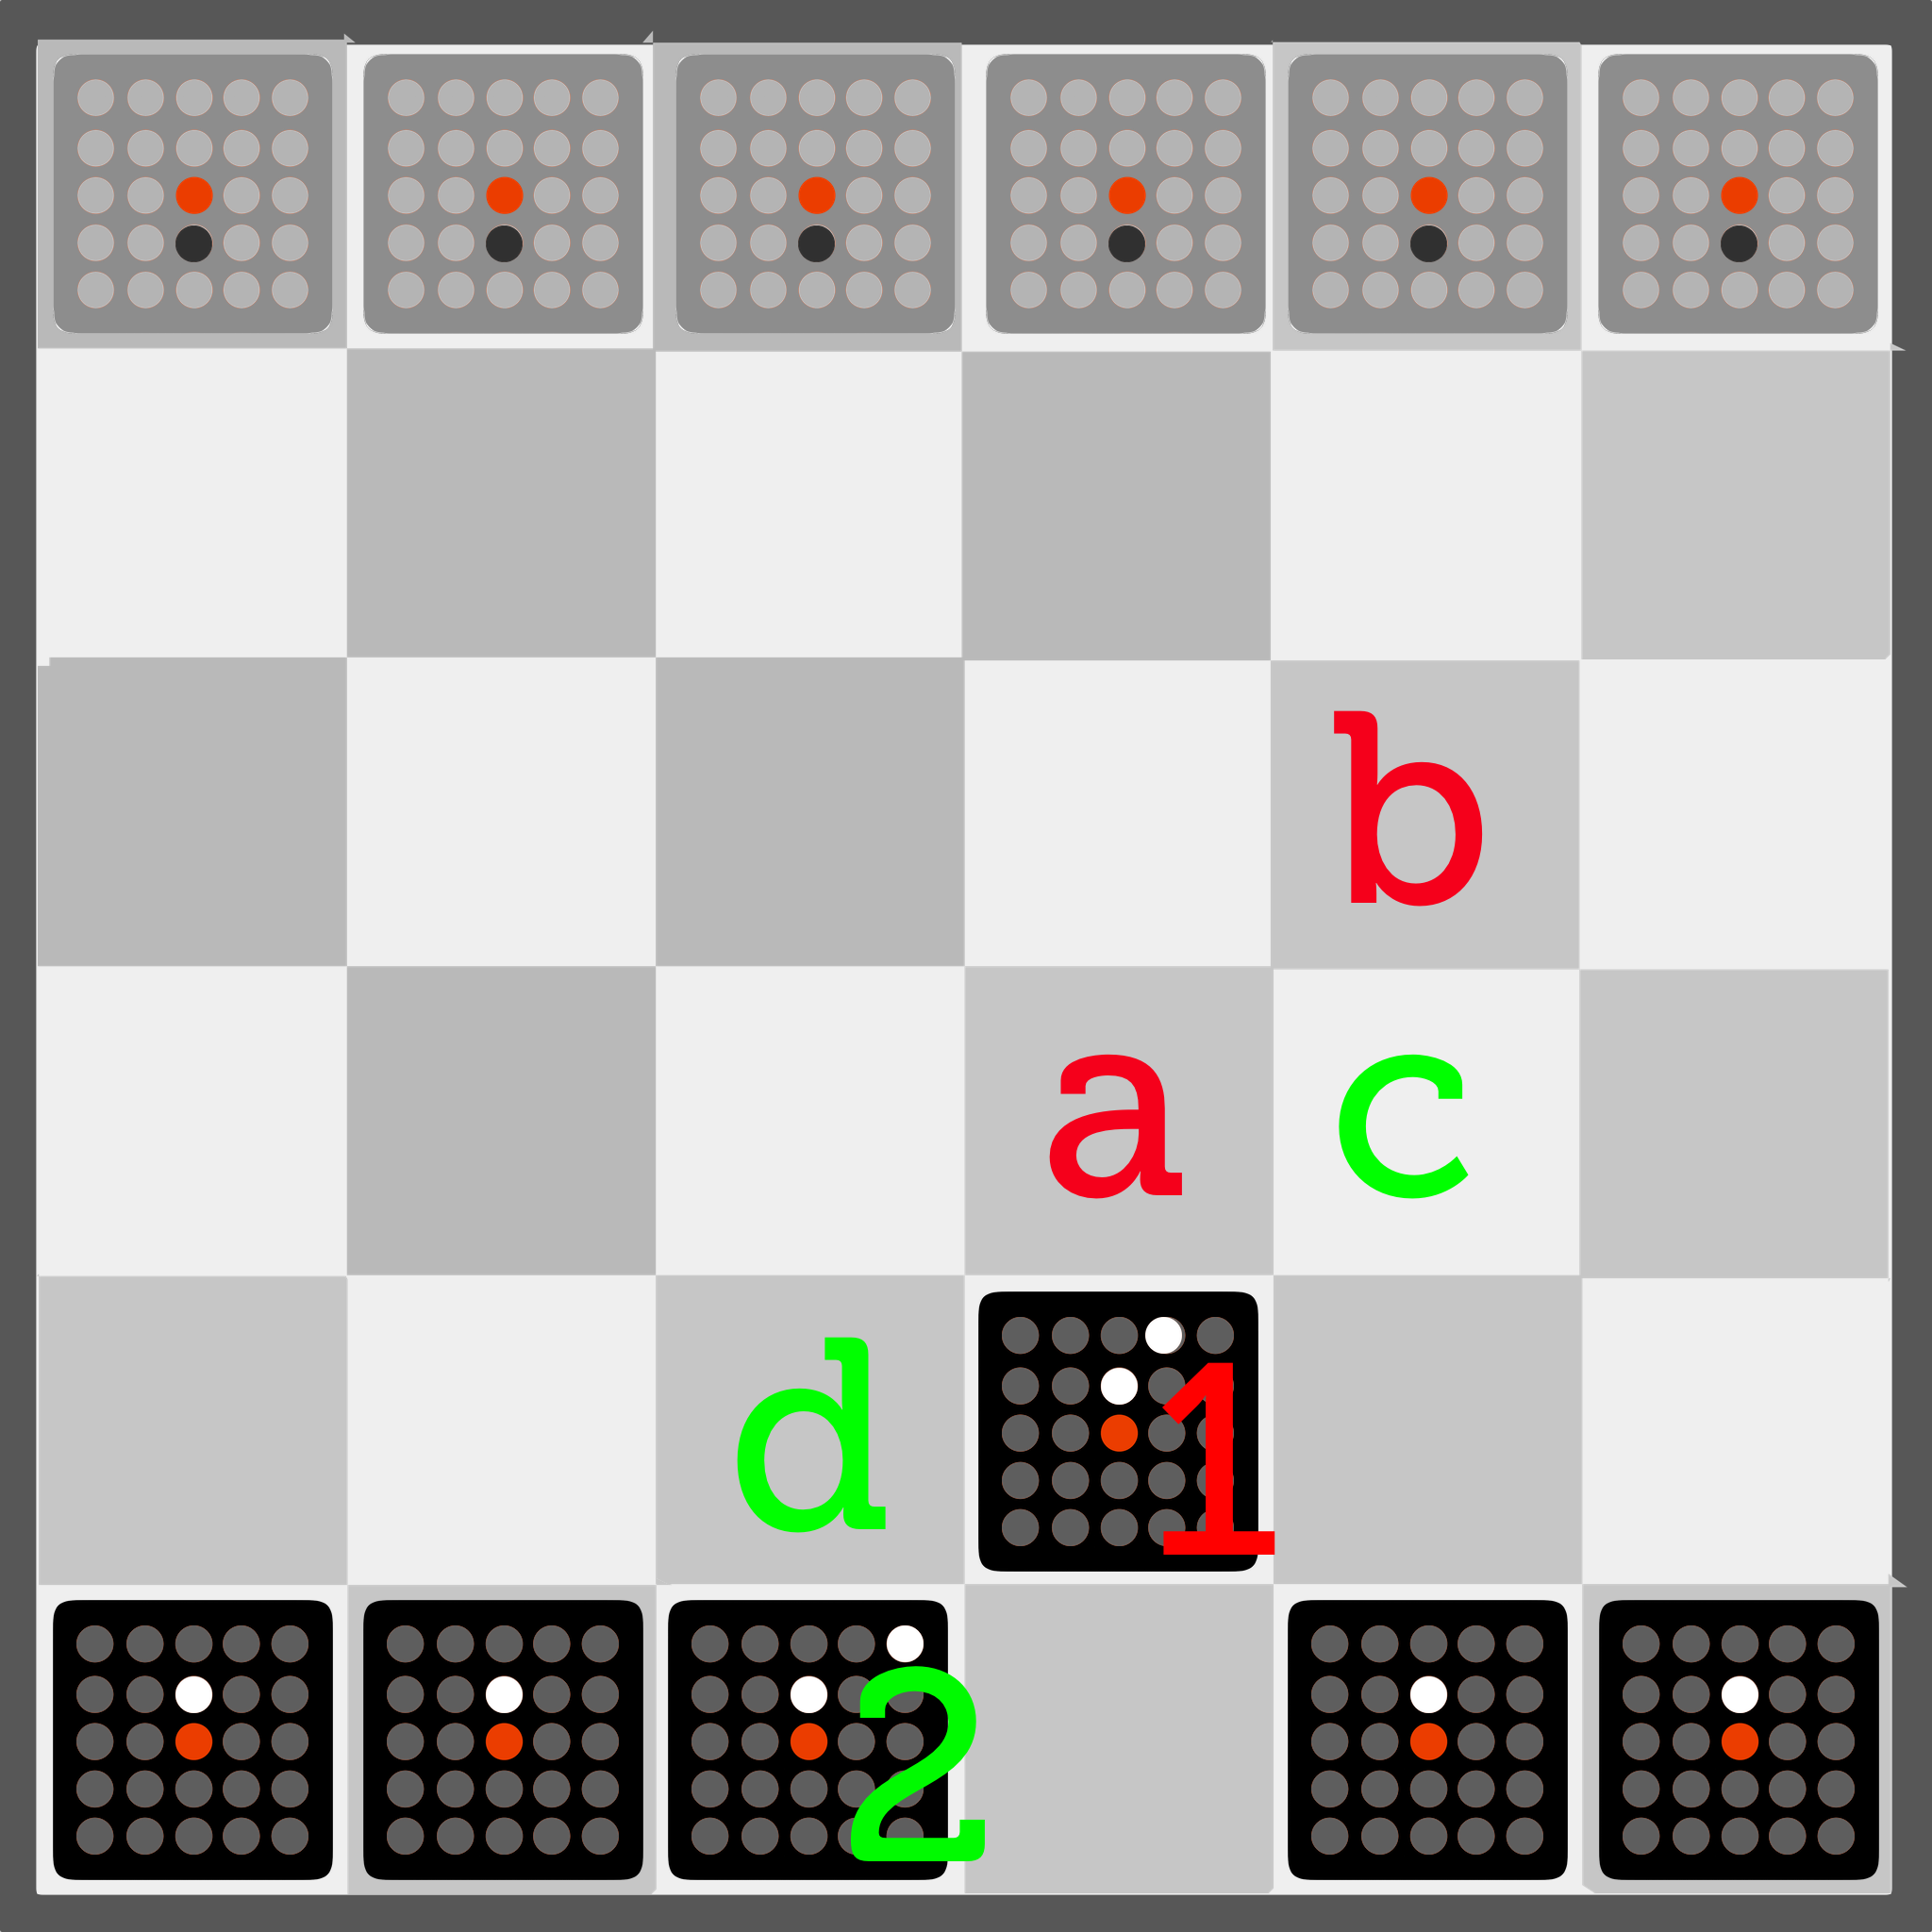
Piece Movement
All pegs in a piece other than the center peg represent the possible moves that piece can take, relative to its position on the board, (represented by its center peg).

For example, the board on the right is after the black player has taken their first turn. They moved a piece (1), and then added a peg to that piece, as well as another piece (2). In subsequent turns, that piece can now potentially move to spaces (a) and (b), and piece (2) can now move to spaces (c), and (d).

- Pegs are never removed from a piece, so each piece will always be able to move one space forward throughout the game. (a) and (d)
- Pieces can jump over other pieces. (c)
- Pieces cannot move off the game board.
- Pieces do not rotate.
- A piece cannot move backwards unless there is a peg behind the piece's center peg.
- When a piece is moved onto another piece, the other piece is removed from the game.
  - Yes, it is possible to capture your own pieces. Though it's probably a bad idea.

Peg Placement
Pegs have to be placed into empty holes in your own pieces, and only into pieces that have not yet been captured.
- You can place your two pegs on different pieces on the same turn.
- You do not need to place either of the pegs on the piece you just moved.

Goal
If you reduce your opponent to just one piece remaining, you win the game.

Secondary goal: In a game where both players have exactly two pieces remaining, a player may instead win the game by filling one of their remaining pieces with pegs.

Links

Latest PnP files: https://tinyurl.com/eigenstate

Cribbage Pegs (on amazon): http://a.co/7jTUhaM
(Note that this is probably enough pegs for 2 PnP sets. It is possible to play with only 1 color of pegs, but 3 allows you to use a separate color for each player as well as the center pegs.)

Martin's blog post introducing Eigenstate: http://chesstris.com/2018/04/15/eigenstate-on-bgg/

Adam's Apple Games: https://adamsapplegames.com/
(This game is slated to be published in late 2018 or 2019.)

